
Company
Logotype

Cone Beam Computed Tomography- Report



Porur Dental X-rays & CBCT

Patient Name : Master. Krish | Date of Report : 16.07.2024
Age/ Gender : 14 years/ Male | Region of Interest : CBCT Sectional Maxilla
Referring doctor: Dr. Abirami | Indication : To rule out bony enlargement in relation to 26, 27, 28.
Clinical Notes: Nil
PATIENT INFORMATION

CBCT- Sectional Maxilla provided
CBCT – IMAGE DETAILS

RADIOGRAPHIC INTERPRETATION

- The alveolar bone in relation to 26, 27 and developing 28 region is present with normal trabecular pattern.
- In relation to the left maxillary sinus, presence of hyperdense opacification occupying more than 1/3rd of the sinus volume measuring 20.81 x 22.69 x 13.46 mm is evident.

RADIOGRAPHIC IMPRESSION

- Pathology in relation to left maxillary sinus.
- Developing 28.

Kindly correlate with clinical findings


IMAGES FOR REFERENCE

RECONSTRUCTED PANORAMIC VIEW
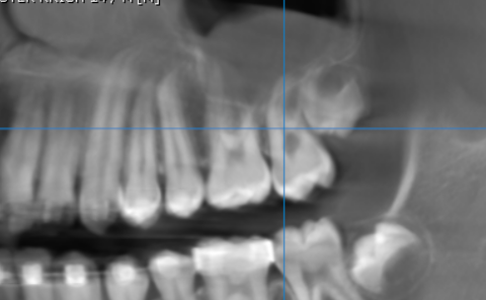

3-DIMENSIONAL VIEW

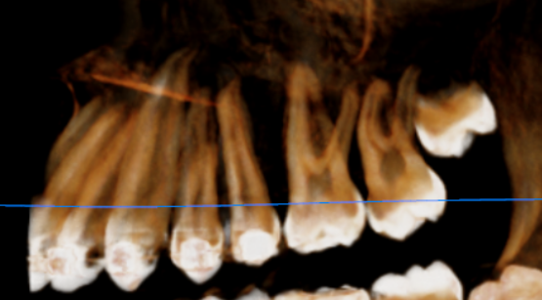

MULTIPLANAR VIEW DISPLAYING THE MAXILLARY SINUS
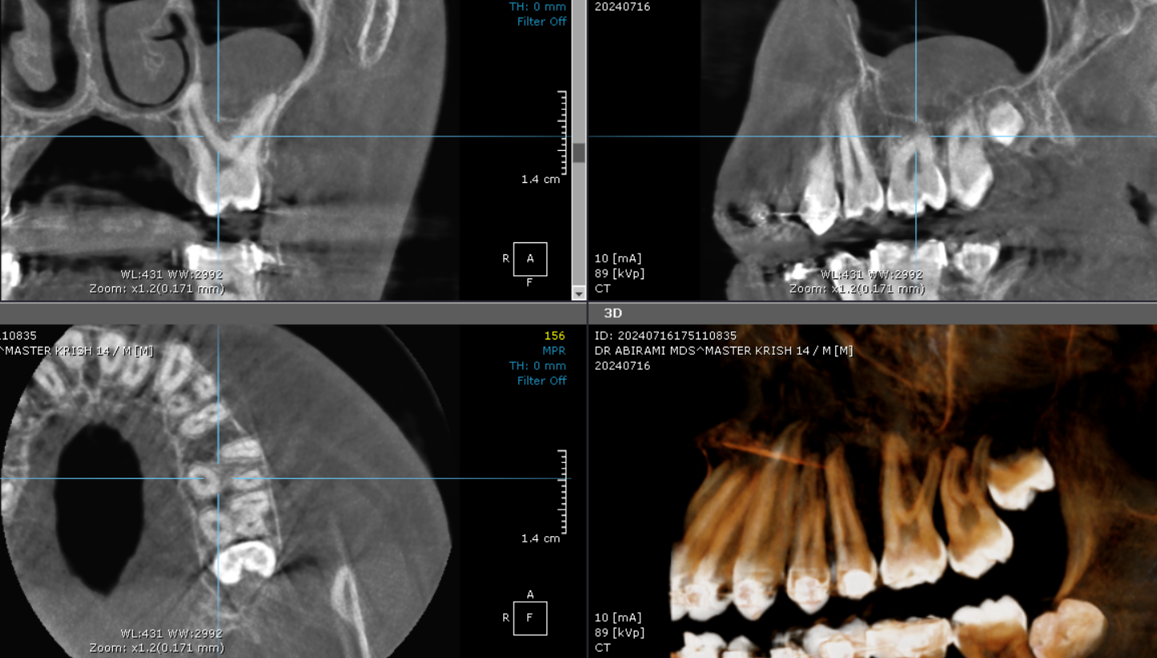

CROSS SECTIONAL VIEW

26, 27, 28 region | 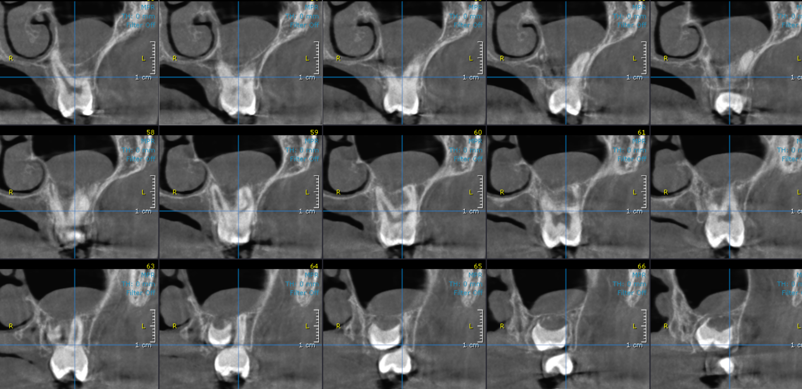

**** End of report ****

